Civil War
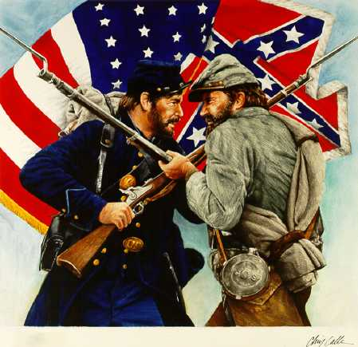

Webquest

Introduction:
Welcome to the Civil War Webquest. By completing this webquest, you will have viewed many wonderful cites on the Civil War that will teach you many things. Make sure that you don’t miss out on the fun and enjoy learning about Civil War. To complete the webquest, go through each of the questions and click on the pictures that go with the questions. This will take you to a website that will allow you to read and answer the question. Once you find the answer, close out the website and go back to the list of questions. If you leave the website open, this may cause your computer to run slower. So, have fun and lets learn about the Civil War!!!

Question One

- What was the main cause of the Civil War? ______________________________________________ ______________________________________________ ______________________________________________________________________________________________________________________________

- 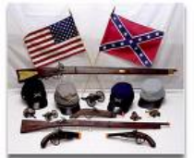What invention helped to contribute to the start of the Civil War and how did it help contribute to the start of the Civil War?

____________________________________________ ____________________________________________ ____________________________________________ ____________________________________________ ______________________________________________________________________________________________________________________________
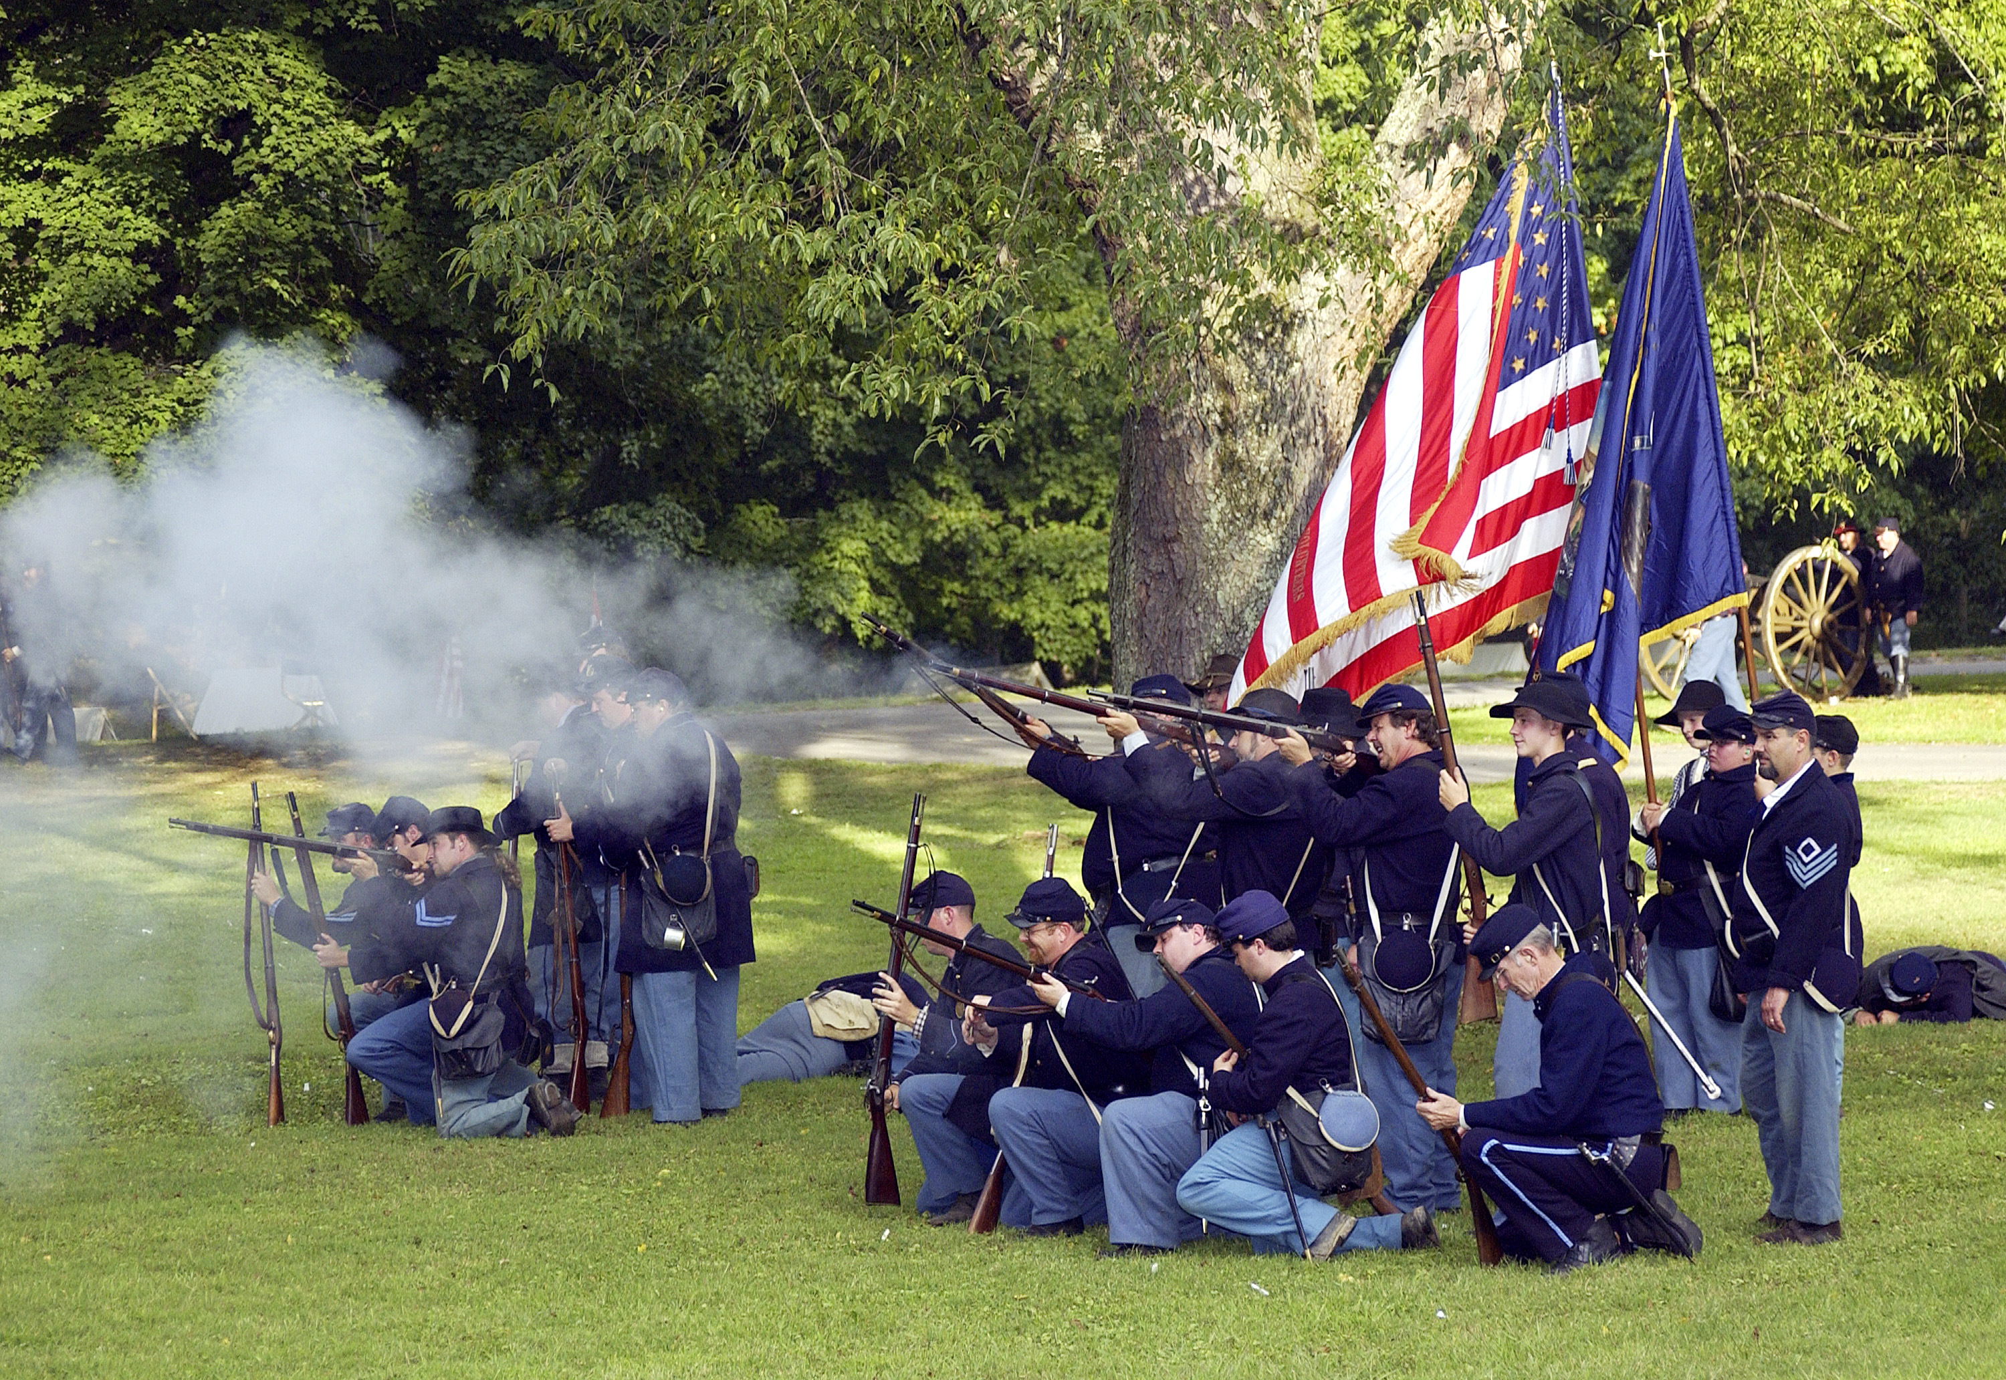
- Another cause of the Civil War was state rights and how this was interpreted by both the North and the South. What does state rights mean and how did this topic in the constitution cause a conflict between the North and the South?
______________________________________________________
______________________________________________________
______________________________________________________________________________________________________________________________________________________________________________________________________________________________________________________________________________________________________________________________________________________________________________________________________________________________

- Another key contributor to the Civil War was the different economic styles in both the North and the South. What were the different economic styles of both the North and the South during the Civil War period and why do you think they could not coexist? (this answer is not on a website you need to expand your thinking about what types of lifestyles the two sides lived.)
_________________________________________________________________________________________________________________________________________________________________________________________________________________________________________________________________________________________________________________________________________________________

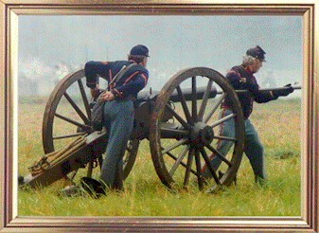
- Before the Civil War, there were many attempts to try and make both sides coexist with one another. In order to do this there were a series of compromises made to help settle disputes. What were the Missouri Compromise of 1820 (1 and 2) and the Compromise of 1850 and what did each try to establish? (Missouri Compromise (1 and 2) is part one and Compromise of 1850 is part 2)
Part 1
Part 2
___________________________________________________________________________________________________________________________________________________________________________________________________________________________________________________________________________________________________________________________________________________________________________________________________________________________________________________________________________________________________
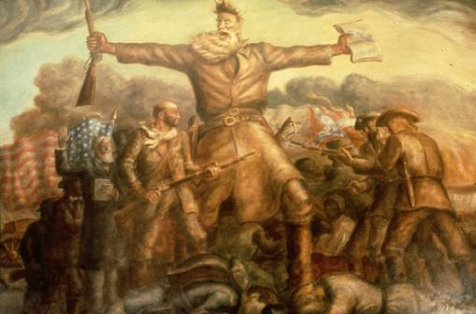
6. What was the Kansas-Nebraska Act and what did it try to accomplish?
_______________________________________ _______________________________________ ________________________________________ ________________________________________ ________________________________________ ________________________________________ ________________________________________ __________________________________________________________________________________________________________________________________________
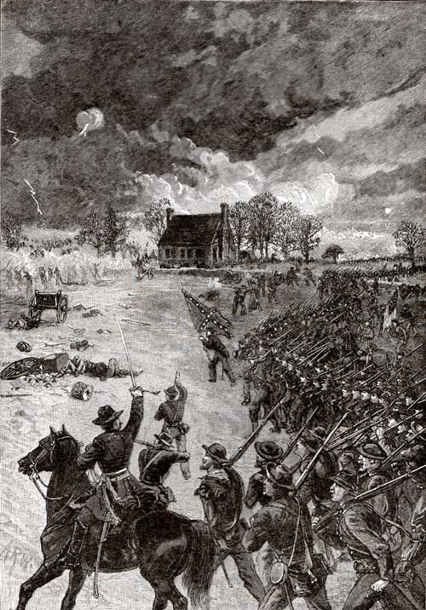
7. What was the Dred Scott Decision and how do you think the North and South reacted to this decision?
_______________________________________________________________ _______________________________________________________________ _______________________________________________________________ _______________________________________________________________ _______________________________________________________________ _______________________________________________________________

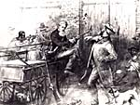
8. What did John Brown do and why do you think it put fear in the Southern States? ______________________________________________________ ______________________________________________________ ______________________________________________________ ______________________________________________________ ______________________________________________________ ______________________________________________________ ______________________________________________________

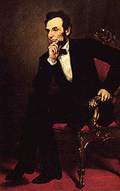
- Who was the President during the time of the Civil War and what does he say he is trying to do by going to war with the South?
_____________________________________________________
_____________________________________________________ _____________________________________________________ ______________________________________________________ ______________________________________________________ ______________________________________________________
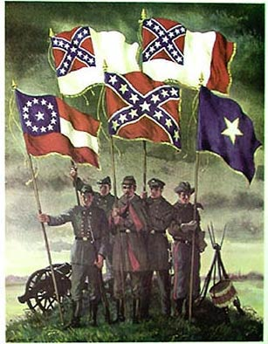
(A little FYI, Lincoln was the first successful candidate from the Republican Party to hold office.)

- Instead of listening to Lincoln’s warning, the southern states succeed the Union and become their own nation. What is the name of this nation and what does the first three paragraphs tell you about the war?
____________________________________________________ ____________________________________________________ ____________________________________________________ _____________________________________________________________________________________________________________________________________________________________________________________________
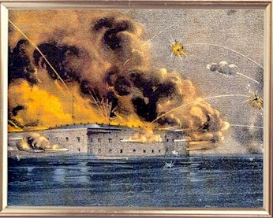
- The South started to attack the North at a fort; this was the first battle of the Civil War. When and where was this battle? Also, how many casualties were there and how did they die?
__________________________________________________ __________________________________________________ __________________________________________________ __________________________________________________
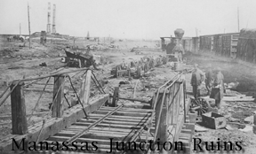
12. Both sides, wanting to end the war quickly, began to march straight for each others capital city (Union = Washington, Confederate = Richmond). On their ways they meet in Virginia near the Manassas and proceeded to have the first land battle of the War. What was this battle called and how did the famous General Jackson receive the name Stonewall? What did this battle prove?
____________________________________________ _____________________________________________ ________________________________________________________________________________________________________________________________________________________________________________________________________________________________________________________________________________________________________________________________________________________________________________________________________________________________________________________________________________________________________________________________________________________________________________________________

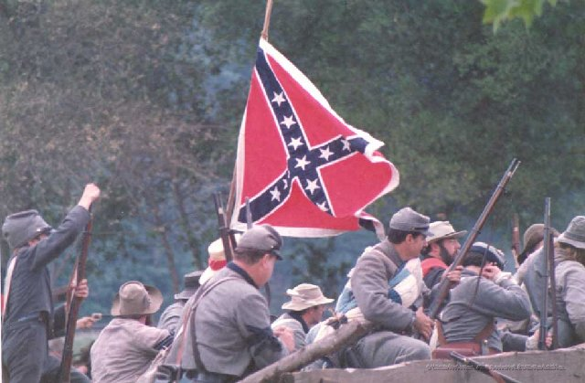
- After being attacked enough at Richmond, Confederate General Robert E. Lee decided that he had enough and began to attack the Union (North) on their own soil. His first encounter was at Antietam in Maryland where he proceeded to have the bloodiest single day of war ever. The number of soldiers lost at this battle compares to other battles how and what do you think this showed the South about the North being that it was the first time they had ever attacked the North on their own land?
___________________________________________________________________________________________________________________________________________________________________________________________________________________________________________________________________________________________________________________________________________________________________________________________________________________________________________________________________________________________________
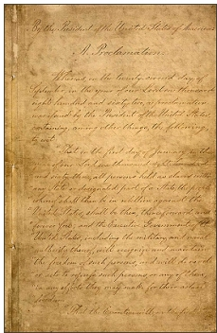
- Lincoln used the Battle at Antietam to issue the Emancipation Proclamation. What is the Emancipation Proclamation and what did it still leave into question according to the Southern States?
_____________________________________________ _____________________________________________ _____________________________________________ ______________________________________________ _______________________________________________ _______________________________________________ _______________________________________________ __________________________________________________________________________________________________________________________________________

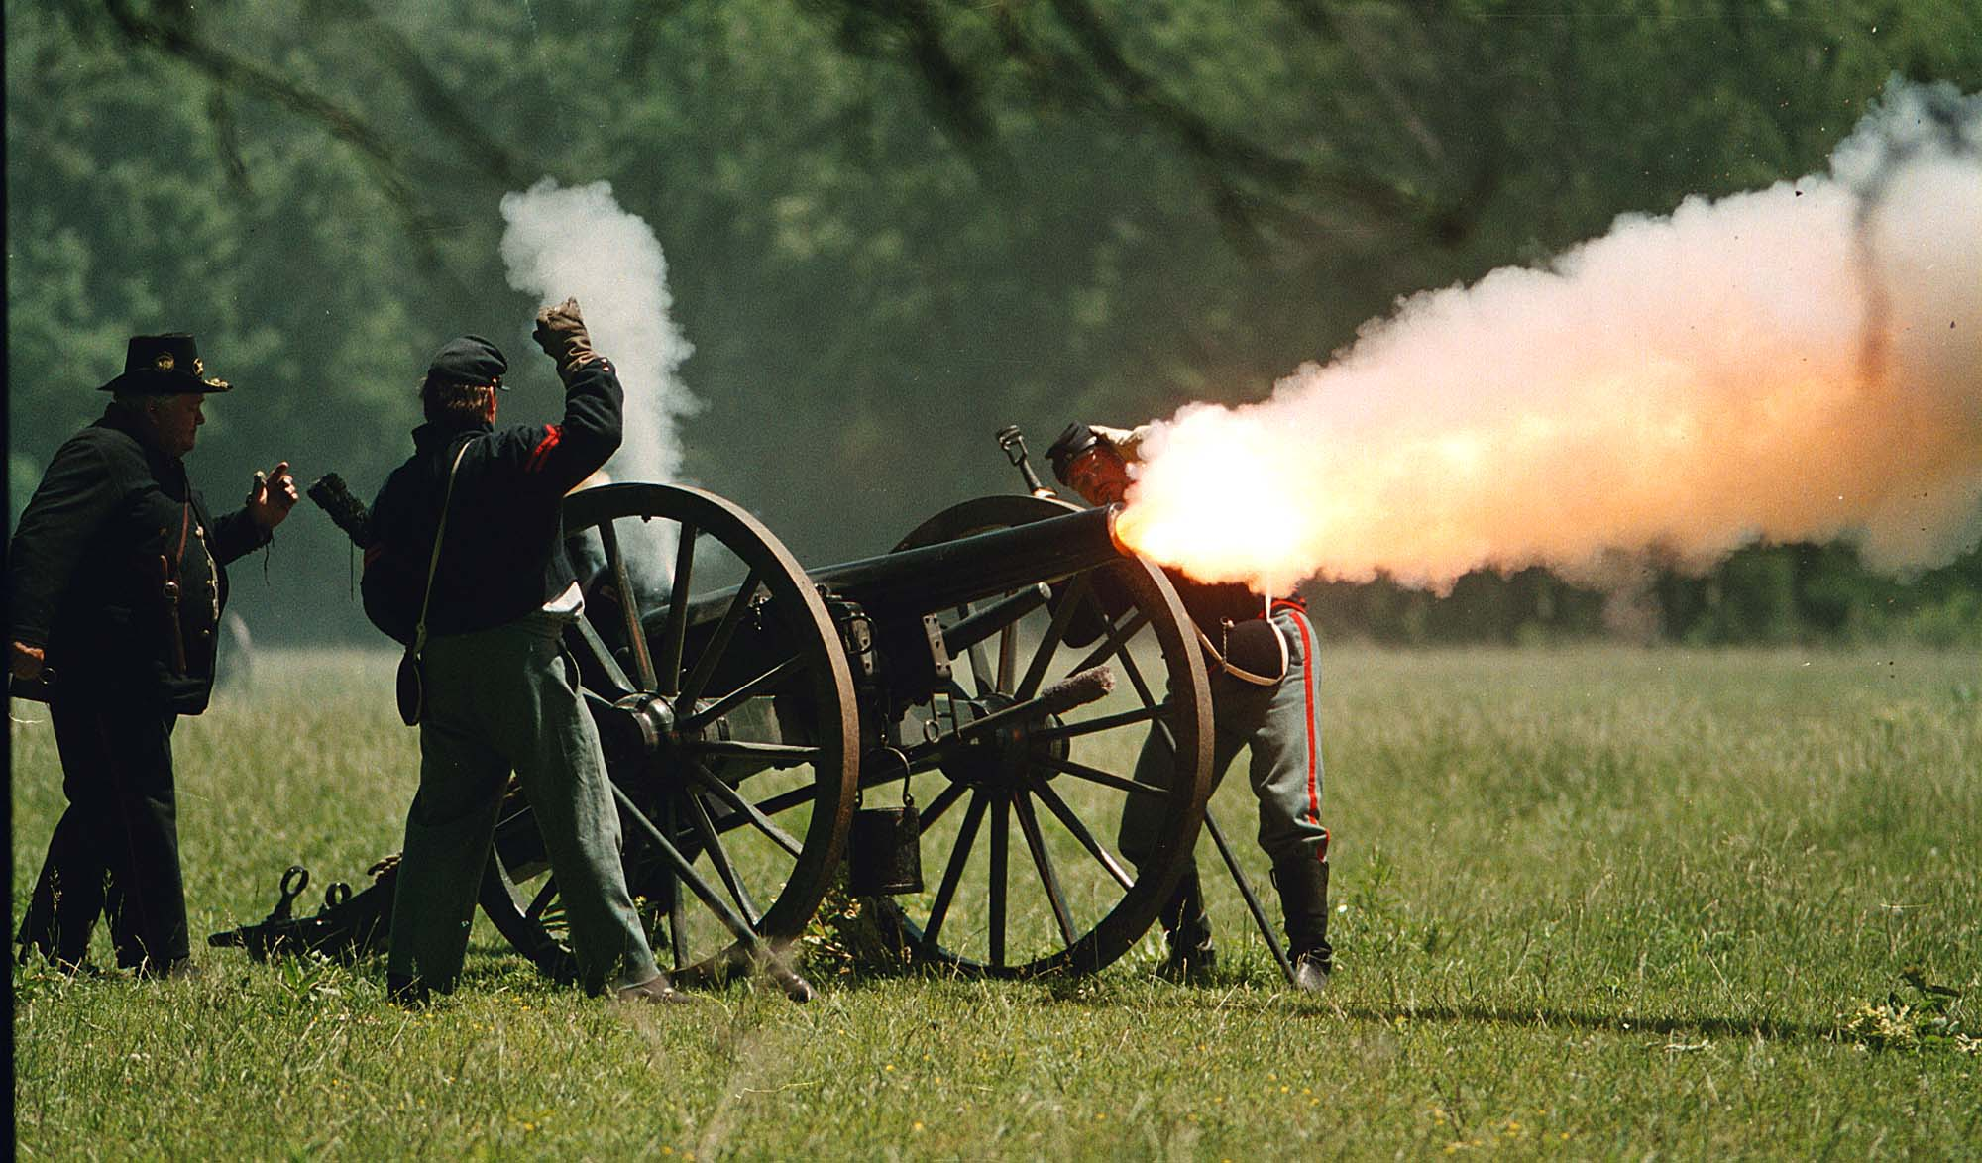
- The North’s economic and military power was beginning to sway the war in their favor. The Confederates faced shortages of food and weapons when they began to fight the Battle of Gettysburg. What was this battle considered; how long did the battle last; how many Americans were involved; what caused General Lee to loose the battle when he had the Union Army on the ropes?
________________________________________________________________________________________________________________________________________________________________________________________________________________________________________________________________________________________________________________________________________________________________________________________________________________________________________________________________________________________________________________________________________________________________________

After the Battle of Gettysburg, Union General Ulysses S. Grant captured the Confederates last major defense in the Mississippi causing the Confederates Army to be separated. Gen. Lee finally surrendered his army to Gen. Grant at Appomattox Court House in Virginia and then a week later the Confederate Army surrendered at the Battle of Bentoville. This was the last major battle of the Civil War. In conclusion to your Civil War Webquest, you need to write a couple paragraphs explaining the following things: how do you think the United States would be different if the South would have won; do you think the Civil War was inevitable or do you think it could have been prevented; and finally what do you now know about the Civil War that you didn’t before.
_______________________________________________________________________________________________________________________________________________________________________________________________________________________________________________________________________________________________________________________________________________________________________________________________________________________________________________________________________________________________________________________________________________________________________________________________________________________________________________________________________________________________________________________________________________________________________________________________________________________________________________________________________________________________________________________________________________________________________________________________________________________________________________________________________________________________________________________________________________________________________________________________________________________________________________________________________________________________________________________________________________________________________________________________________________________________________________________________________________________________________________________________________________________________________________________________________________________________________________________________________________________________________________________________________________________________________________________________________________________________________________________________________________________________________________________________________________________________________________________________________________________________________________________________________________________________________________________________________________________________________________________________________________________________________________________________________________________________________________________________________________________________________________________________________________________________________________________________________________________________________________

Websites for Questions
Question 1. http://www.ngeorgia.com/history/why.html
Question 2. http://ehistory.osu.edu/world/articles/ArticleView.cfm?AID=31
Question 3. http://www.civilwarhome.com/statesrights.htm
Question 4. None
Question 5. Part 1 http://en.wikipedia.org/wiki/Missouri_Compromise
Part 2 http://en.wikipedia.org/wiki/Compromise_of_1850
Question 6. http://www.historyplace.com/lincoln/kansas.htm
Question 7. http://www.historyplace.com/lincoln/dred.htm
Question 8. http://www.pbs.org/wgbh/aia/part4/4p1550.html
Question 9. http://www.whitehouse.gov/history/presidents/al16.html
Question 10 http://www.civilwarhome.com/csa.htm
Question 11 http://www.civilwarhome.com/ftsumter.htm
Question 12 http://library.thinkquest.org/3055/netscape/battles/bullrun.html
Question 13 http://www.nps.gov/archive/anti/battle.htm
Question 14 http://www.archives.gov/exhibits/featured_documents/emancipation_proclamation
Question 15 http://www.historyplace.com/civilwar/battle.htm

