Name________________________________________________ Date_______________________
Explorer Internet Scavenger Hunt
Georgia Performance Standard: SS4H2 The student will describe European exploration in North America. a. Describe the reasons for, obstacles to, and accomplishments of the Spanish, French, and English explorations of John Cabot, Vasco Núñez de Balboa, Juan Ponce de León, Christopher Columbus, Henry Hudson, and Jacques Cartier. b. Describe examples of cooperation and conflict between Europeans and Native Americans.
DIRECTIONS: Click on each hyperlink to read the text to answer the questions below.
Christopher Columbus
- Christopher Columbus was born in Italy but his journeys were financed by what country? What were the names of that country’s king and queen?

- To what land was Columbus trying to find a shortcut?

- European explorers often searched for ___________ during their explorations so that they could become rich.

- What were the names of the three ships under Columbus’ command?

- Watch the movie about Christopher Columbus. (4 minutes 21 seconds) Write 3 facts that you learned in the movie.

1. ____________________________________________________
2. ____________________________________________________
3. ____________________________________________________
6. Take the short online quiz about Christopher Columbus.
7. Play the online Quia quiz (Rags to Riches) about Columbus. See how high you can get
after three attempts. What was your highest scoring amount?

- Draw and label the routes of the four different voyages of this explorer.
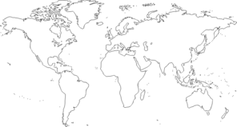
- What happened after Columbus’s third voyage?

- What group of people did the English want to become Christians but were later treated badly and made slaves?

- Play the game Walk the Plank. You’ll answer 10 questions. Scroll over the sailors for the answer choices.

- Draw a picture of a ship that Columbus would have sailed.

Name________________________________________________ Date_______________________
Explorer Internet Scavenger Hunt
Georgia Performance Standard: SS4H2 The student will describe European exploration in North America. a. Describe the reasons for, obstacles to, and accomplishments of the Spanish, French, and English explorations of John Cabot, Vasco Núñez de Balboa, Juan Ponce de León, Christopher Columbus, Henry Hudson, and Jacques Cartier. b. Describe examples of cooperation and conflict between Europeans and Native Americans.
DIRECTIONS: Click on each hyperlink to read the text to answer the questions below.
John Cabot
- In what country was John Cabot born?

- Cabot’s birth country wouldn’t sponsor a trip, so he moved to what country?

- This explorer was in search of __________________________.

- What was the name of John Cabot’s ship?

- Read the information about boats. Take the short quiz. (You have to have “wait time” for the next question to appear.) Use the following words to label the ship: ∙hull ∙deck ∙mast

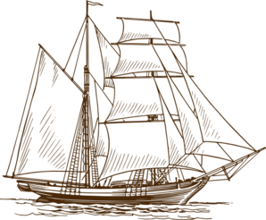

- One obstacle that John Cabot encountered was on June 11, 1498. Because of the cold and icebergs, Cabot’s crew ____________ which means they took over the ship.
- Read about the different navigational tools used by European explorers. Match the clue to each picture by writing the letter to define each instrument.
Instrument | 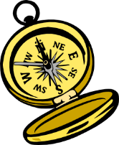compass | 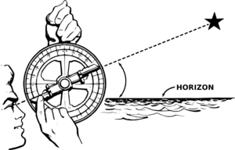astrolabe | 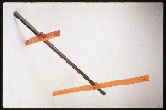crosstaff | quadrant | sextant
Definition
- Used to navigate the ship. This instrument has a magnetized needle which aligns itself to the magnetic fields of the earth.
- Used to determine the altitude of the sun, moon, and stars. Replaced by more specialized and accurate instruments.
- Used to determine the angle between the horizon and the sun, moon or stars in order to find the latitude. Replaced the astrolabe.
- Used to determine the altitude of the sun, moon, and stars. Better tool than an astrolabe. Consisted of a 90 degree graduated arc with movable radius for measuring angles.
- Used to determine the altitude of the sun, moon, and stars. Used mostly in the early 1500s. Consisted of a square shaft and a sliding cross-piece set at right angles to the shaft.

- Click on the map to view the land that Cabot explored. Then watch the following video about John Cabot (2 minutes 5 seconds). Stop the video at 1 minute 6 seconds and draw the route on the map below. Finish watching the video.
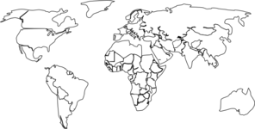
Name________________________________________________ Date_______________________
Explorer Internet Scavenger Hunt
Georgia Performance Standard: SS4H2 The student will describe European exploration in North America. a. Describe the reasons for, obstacles to, and accomplishments of the Spanish, French, and English explorations of John Cabot, Vasco Núñez de Balboa, Juan Ponce de León, Christopher Columbus, Henry Hudson, and Jacques Cartier. b. Describe examples of cooperation and conflict between Europeans and Native Americans.
DIRECTIONS: Click on each hyperlink to read the text to answer the questions below.
Vasco Nunez de Balboa
- In what country was Vasco Nunez de Balboa born?

- Balboa was a conquistador (soldier). What was he searching for in South America?

- Balboa was a farmer in ________________. He was unsuccessful and became poor.

- Balboa stowed away on a ship to going to San Sebastian. What had happened there before Balboa arrived?

- Balboa established and became governor of the first settlement in South America called ___________________________.

- Watch the video (1 minute 32 seconds). Write 3 facts that you learned.

1. _________________________________________________________
2. _________________________________________________________
3. _________________________________________________________

- During Balboa’s explorations of South America, he killed hundreds of Indians along the way before being the first European to see what ocean?

- Balboa was framed for treason by his best friend and was _________________, (Balboa was actually innocent of that crime.)

- Look at the map. Draw and label Balboa’s routes during his explorations.
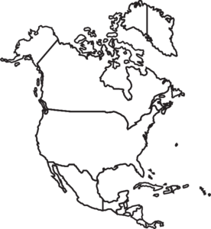

Name________________________________________________ Date_______________________
Explorer Internet Scavenger Hunt
Georgia Performance Standard: SS4H2 The student will describe European exploration in North America. a. Describe the reasons for, obstacles to, and accomplishments of the Spanish, French, and English explorations of John Cabot, Vasco Núñez de Balboa, Juan Ponce de León, Christopher Columbus, Henry Hudson, and Jacques Cartier. b. Describe examples of cooperation and conflict between Europeans and Native Americans.
DIRECTIONS: Click on each hyperlink to read the text to answer the questions below.
Juan Ponce de Leon
- In what country was Juan Ponce de Leon born?

- With what famous explorer did Ponce de Leon join?

- Ponce de Leon was appointed governor of what province?

- King Ferdinand of Spain appointed Ponce de Leon as governor of what island?

- Ponce de Leon began to search for something a magical water source that made you stay young. What was he searching for?

- What land did this famous explorer name after the beautiful flowers that he saw?

- The first Spanish settlement in North America was started by Ponce de Leon. What was its name?

- Ponce de Leon landed in Florida years later but was wounded by Native Americans. What was the result of that confrontation?

- Look at the map. Draw and label the routes during Ponce de Leon’s exploration.
- Watch the video about Juan Ponce de Leon (2 minutes 21 seconds). Write 3 facts that you learned from the video.

1. _________________________________________________________
2. _________________________________________________________
3. _________________________________________________________
11. Read the online poem about Ponce de Leon. Write a quatrain (4 line poem) about this explorer.
____________________________________
________________________________________________________________________________________________________________________________________________________________________________________________________________________________________________________________________
Name________________________________________________ Date_______________________
Explorer Internet Scavenger Hunt
Georgia Performance Standard: SS4H2 The student will describe European exploration in North America. a. Describe the reasons for, obstacles to, and accomplishments of the Spanish, French, and English explorations of John Cabot, Vasco Núñez de Balboa, Juan Ponce de León, Christopher Columbus, Henry Hudson, and Jacques Cartier. b. Describe examples of cooperation and conflict between Europeans and Native Americans.
DIRECTIONS: Click on each hyperlink to read the text to answer the questions below.
Jacques Cartier
- In what country was Jacques Cartier born?

- What were the reasons for Cartier’s exploration?

- King Francis I of France sent Cartier to the “northern lands” (Cartier’s 1st voyage). With 2 ships and 61 men, Cartier explored the west coast of _________________ and explored the island called ________________.

- In Cartier’s 2nd voyage, this explorer sailed with two captured Indians as guides and heard about rivers that led to what?

- On Cartier’s 3rd voyage, this explorer captured some of the Iroquois chiefs and went back to France. He thought he found ____________ and __________ near Quebec.

- How did France react to Cartier after his last voyage?

- Watch the video about Jacques Cartier. Write 3 facts that you learned.

1. _________________________________________________________
2. _________________________________________________________
3. _________________________________________________________
8. Look at the map. Draw and label Jacques Cartier’s journeys.
9 Go to Jeopardy Labs. Play the game as 1 player. Out of the 8 sections, how many did you get correct?

Name________________________________________________ Date_______________________
Explorer Internet Scavenger Hunt
Georgia Performance Standard: SS4H2 The student will describe European exploration in North America. a. Describe the reasons for, obstacles to, and accomplishments of the Spanish, French, and English explorations of John Cabot, Vasco Núñez de Balboa, Juan Ponce de León, Christopher Columbus, Henry Hudson, and Jacques Cartier. b. Describe examples of cooperation and conflict between Europeans and Native Americans.
DIRECTIONS: Click on each hyperlink to read the text to answer the questions below.
Henry Hudson
- In what country was Henry Hudson born?

- Why did the Muscovy Company hire Henry Hudson?

- Hudson sailed on the Hopewell through the Arctic Ocean and reached the northern shore of what country?

- After reaching Norway, Hudson chose another company to sponsor his journeys. What was the name of that company?

- What was the name of the ship that Hudson sailed when with this second company?

- Hudson sailed under the companies Virginia Company and the British East India Company in what ship?

- Hudson journeyed to Greenland, Iceland, and Labrador before his crew did what after being trapped in the ice?

- Look at the map. Draw and label Henry Hudson’s routes of his explorations.
- Watch the video about Henry Hudson. Write 3 facts that you learned in the video.

1. _________________________________________________________
2. _________________________________________________________
3. _________________________________________________________

- Play this online Jeopardy game. Out of the 6 sections, how many did you get correct?

- Hudson made the whaling industry popular with his travels in the Arctic. Read about whales. Click on the whale that you would like to draw. Draw the whale of your choice below. Label.

Explorers Review
(Some of these games review a wider range of European explorers that Georgia Performance Standards.)

- Click on the link. Play theQuia European explorers game 3 times (Rags to Riches). What was your highest amount won?

- Click on the link. Play this Quia Jeopardy game. How many did you get correct?

- Click on the link. Select one or more games, activities, or powerpoints as a review. (The powerpoint may or may not be a game.) After you choose a game then leave that tab open. Set the time for 5 minutes on another page (and keep that tab open) You’ll have at least two tabs open at one time.

- Complete the timeline below.
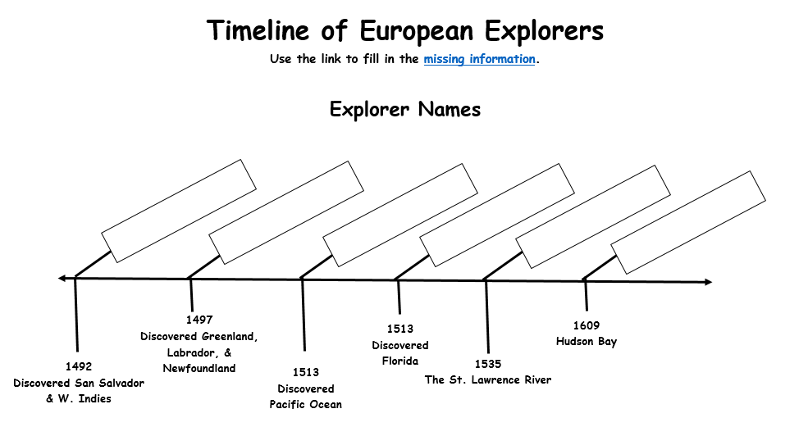

***If you want to teach your students to read the content on several sites to find the best information, then look at this tongue-in-cheek site. The teachers who created this site included erroneous information as well as facts. You could use this site to find the errors and the information that is true.
http://allaboutexplorers.com/explorers/cabot/

